Income Statement Dashboard

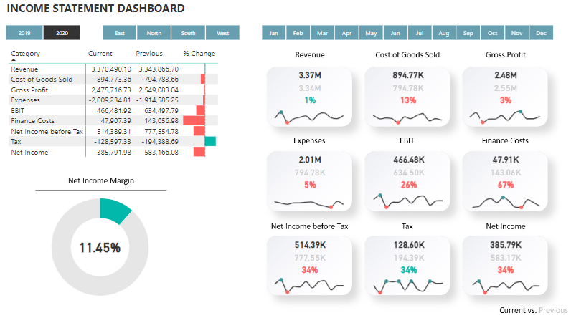

Summary

Details

Objective

Data Collection and Transformation

Data Modeling

Measures

Dashboard Design and Development

# Summary

The goal of this project is to create a complete Income Statement Dashboard in Power BI that compares two years of financials. The dataset used included simple journal records and a chart of accounts. Based on these sources the data was transformed using Power Query, Data Model was created, and Income Statement categories were calculated and visualized. The numbers were presented in the form of a matrix comparing current- and previous-year values, a donut chart for Net Income Margin, and KPI cards for each of Income Statement categories, including current and previous value, percent change, and a sparkline for 12-month timeline. On top of that the slicers were created to enable filtering by years, months and divisions. As a result, the dashboard facilitated a comprehensive view on financial performance and enabled stakeholders to make informed decisions based on detailed and actionable data.

# Details

## Objective

To create a complete Income Statement Dashboard to compare two years of financials, providing detailed insights into the company's financial performance through various visualizations.

## Data Collection and Transformation

Utilized simple journal records and a chart of accounts, transformed and cleaned the data using Power Query. The transformation included the following steps:

* unpivoting credit and debit column to have a transaction type in one column for better analysis
* creation of custom column to negate debit values and leave credit values as positive by using IF statement:

=if [Type] = "Dr" then [Amount]*-1 else [Amount]

* creation of Division table out of Journal table, enabling filtering dashboard by division
* creation of custom table with a Calendar based on min and max dates from Journal table, enabling time intelligence calculations:

= {Number.From(List.Min(Journal[Date]))..Number.From(List.Max(Journal[Date]))}

## Data Modeling

Created a star schema by connecting the fact table (Journal) to the dimension tables (COA, Division, Calendar). The relationship is one-to-many.

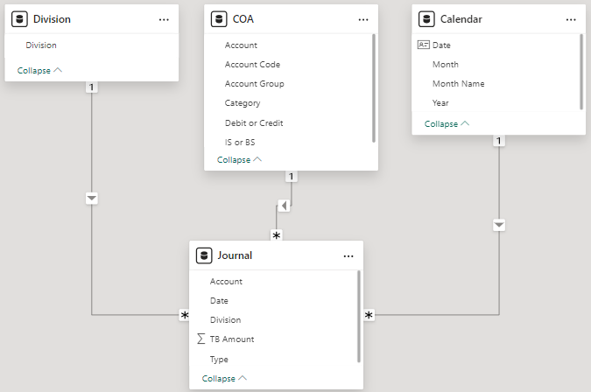

## Measures

Created measures table to calculate the reporting value, and then separate Income Statement values by using CALCULATE function. Then, missing categories, such as Gross Profit, EBIT, Net Income before tax, Tax, Net Income have been calculated out of existing measures.

Reporting Value = SUM(Journal[TB Amount])

Revenue = CALCULATE([Reporting Value],COA[Category] = "Revenue")

Cost of Goods Sold = CALCULATE([Reporting Value],COA[Category] = "Cost of Goods Sold")

Gross Profit = [Revenue] + [Cost of Goods Sold]

Expenses = CALCULATE([Reporting Value],COA[Category] = "Expenses")

EBIT = [Gross Profit] + [Expenses]

Finance Costs = CALCULATE([Reporting Value],COA[Category] = "Finance Costs")

Net Income before Tax = [EBIT] + [Finance Costs]

Tax = IF([Net Income before Tax]>0,-[Net Income before Tax]*0.25,0)

Net Income = [Net Income before Tax] + [Tax]

## Dashboard Design and Development

Designed the dashboard with a matrix for year-over-year comparison, a donut chart for Net Income Margin, KPI cards for key metrics, including 12-month sparkline, and added slicers for filtering by year, month, and division. The background has been created in PowerPoint and added through page formatting.

1. Income Statement Matrix

To create the matrix I had to add a Layout table with individual IS categories

and then assign corresponding current-year values by utilizing the measure with DAX code below.

Current =

VAR CurrentCategory = SELECTEDVALUE(Layout[Category])

VAR Amount = SWITCH(TRUE(),

CurrentCategory = "Revenue", [Revenue],

CurrentCategory = "Cost of Goods Sold", [Cost of Goods Sold],

CurrentCategory = "Gross Profit", [Gross Profit],

CurrentCategory = "Expenses", [Expenses],

CurrentCategory = "EBIT", [EBIT],

CurrentCategory = "Finance Costs", [Finance Costs],

CurrentCategory = "Net Income before Tax", [Net Income before Tax],

CurrentCategory = "Tax", [Tax],

CurrentCategory = "Net Income", [Net Income],

0)

RETURN

Amount

Previous year value was calculated with CALCULATE and SAMEPERIODLASTYEAR function and added to the matrix.

Previous = CALCULATE([Current], SAMEPERIODLASTYEAR('Calendar'[Date]))

% Change was calculated with DIVIDE function asd also added to the matrix.Then the conditional formatting was applied to show data bars, differentiating between negative and positive % values.

% Change = DIVIDE([Current]-[Previous], ABS([Previous]),0)

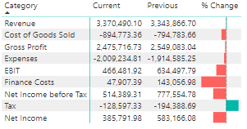

1. Net Income Margin

This metric was presented with a donut chart visual and required creation of additional measures - Net Income Margin and Inverted Net Income Margin:

Net Income Margin = [Net Income] / [Revenue]

Inv Net Margin = 1 - [Net Income Margin]

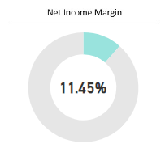

1. KPIs

To present KPIs related to all Income Statement categories, a new measure table was created with the calculations for current year value, previous year value, and % change, eg:

Revenue Current = CALCULATE([Current], Layout[Category] = "Revenue")

Revenue Previous = CALCULATE([Previous], Layout[Category] = "Revenue")

Revenue % Change = CALCULATE([% Change], Layout[Category] = "Revenue")

To remove minus sign from negative amounts, the ABS function was utilized in calculation, eg:

Tax Current = ABS(CALCULATE([Current], Layout[Category] = "Tax"))

To remove sign from a percentage value, the custom formatting was applied:

0%;0%;0%

KPIs were visualized with a Card visual and a sparkline (imported from file) for a 12-month period. The % change value was colored based on a condition if it’s negative or positive.

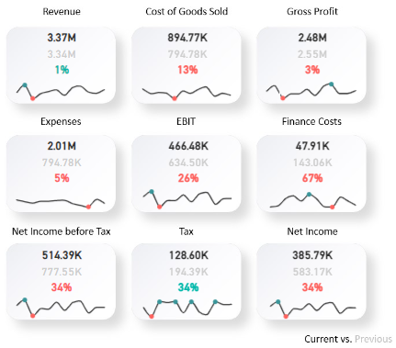

## Impact and Insights

The potential insights that can be derived from the Income Statement Dashboard include:

* Year-over-Year performance comparison: evaluate changes in key profitability metrics like Gross Profit or Net Income, and analyze the factors contributing to these changes.
* Net Income Margin analysis: compare Net Income Margin across different divisions or time periods to identify areas of strength and weakness.
* Monthly performance tracking: analyze monthly fluctuations in financial performance to detect anomalies or trends that require further investigation.
* Division performance: assess the contribution of each division to overall profitability, enabling strategic decision-making.
* Target achievement: track KPIs against targets or benchmarks to evaluate the company’s performance relative to its goals.
* Trend analysis: use sparklines to identify long-term trends in financial performance, helping to inform strategic planning and forecasting.